JCADA
Board Member Application
FY23 (July 1, 2022 - June 30, 2023)

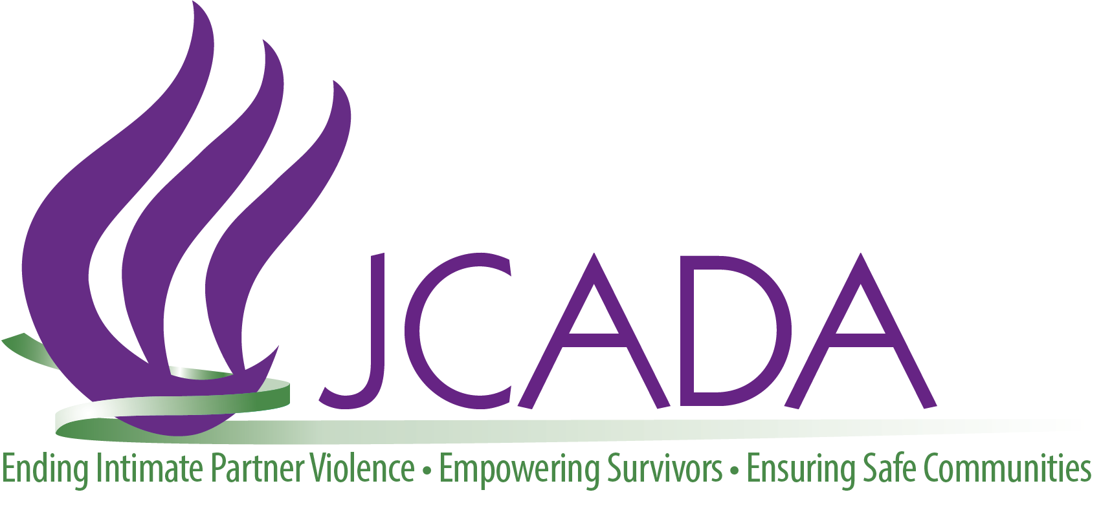

Thank you for your interest in a position on JCADA’s Board of Directors.
We hope you will take this opportunity to learn more about JCADA, our mission, and the responsibilities of the Board of Directors. We believe the more you learn about JCADA and our work, the more you will want to partner with us in working to end intimate-partner violence in our community.

JCADA enjoys a rich history in the Jewish Community and in the D.C., Maryland, and Virginia area as a whole. Our Board and our organization reflect the commitment to Tikkun Olam, the Jewish value of repairing the world, which grounds our work towards a future free of intimate-partner violence, and one in which our services are no longer needed.

This application is just the beginning of the process in becoming a new Board Member. Interviews and Board approval are next steps in the process. Attracting successful and quality business and community leaders helps us to achieve a successful governing board. And ensuring that JCADA is a good fit for you and you for us is crucial in quality Board development and the overall success of our organization.

If you have an interest in exploring a Board position with JCADA, please complete this application and send it to Amanda Katz, Executive Director at amanda@jcada.org. Please call her at 301.315.8040 if you have any questions.

Thank you for your interest in a potential Board of Directors position with JCADA!

JCADA'S mission is to support victims of intimate partner violence to become empowered and live safely; educate the community about intimate partner violence and the appropriate responses; and prevent future generations from experiencing intimate partner violence.
About JCADA

JCADA was founded by a coalition of women who recognized the prevalence and impact of domestic violence in the Jewish community and the need for an organization to support and counsel the victims. In its first year, JCADA had a tiny staff and budget and helped three victims. Over the following 20 years, JCADA’s services to the wider Washington area community have grown.

Some of the impressive and humbling data from our recently-completed 20th year includes a staff of 23, as well as interns and members of Friends of JCADA, our community engagement program. We provided free counseling, legal services, and victim advocacy to 1335 victims and survivors of intimate partner violence in Maryland, Virginia, and the District of Columbia; and we conducted 145 prevention and education programs to over 4,500 adults, teens, and youth.

We have grown our budget to just over $2M, which includes more than $1.5M in government grants. We have been able to support victims and survivors, educate the community, and work towards preventing abuse and intimate partner violence in future generations.

JCADA serves clients throughout the Greater Washington Metropolitan Region. Clients access JCADA from a variety of sources, including friends, family, other victim-service providers, and clergy, and by reading the JCADA signs posted in many bathroom stalls.

JCADA serves all clients, regardless of religion, but because of our strong connections to the Jewish community, 25 percent of JCADA’s direct-service clients identify themselves as Jews. Other clients have self-identified as Christian, Buddhist, Muslim, Sikh, and Hindu.

Ninety-two percent of our clients are female and over this past year, our clients ranged in ages from 14 to 87.

JCADA's talented staff included professionals who speak Spanish and Hebrew in addition to English. We therefore attract and can serve clients with limited English proficiency.

JCADA offers direct support to those affected by intimate partner violence through clinical, legal, and victim advocacy services. All direct client services are offered free of charge to clients at JCADA and are not time bound.

JCADA’s Clinical Team makes use of cutting-edge, evidence-based strategies to help people process trauma. JCADA’s Clinical Director is certified in Eye Movement Desensitization and Reprocessing®, and many of our clinicians are also able to provide this therapy. JCADA clinicians are also trained in Somatic Experiencing® and Sand Tray Therapy. These innovative therapies can be life changing for many clients.

JCADA’s Legal Team provides direct representation to survivors of intimate partner violence who are seeking protective orders primarily in the courts of Montgomery County, Md. and Fairfax County, Va. We also assist survivors with legal issues directly resulting from the issuance of a protective order, such as lease termination, and provide assistance, education, and guidance to survivors asserting their crime-victims’ rights stemming from an incident of intimate partner violence.

JCADA’s Victim Advocacy Program helps our clients meet their basic human needs, including but not limited to food, shelter, clothing, safety, and healthcare. Our Facility Dog, Tahoe, was trained at Hero Dogs, Inc. He is available to meet with clients in sessions and accompany them to court and other hearings.

JCADA offers a variety of different educational workshops for groups and individuals looking to promote healthy relationships, and create safe school, work, and religious communities. Each program is tailored to a group's specific audience, goal, and needs. JCADA developed the AWARE® program prevention initiative for students in 6th grade to college. Since its creation in 2009, AWARE® has engaged over 40,000 teens, parents, and educators.

Our community engagement program, Friends of JCADA, actively engages community members in JCADA’s work through interactive programs, regular updates, and legislative advocacy. Members have free access to learning opportunities every other month that are designed to increase knowledge, expand thinking, and strengthen our mutual resolve to support survivors of intimate partner violence.

JCADA’s Core Values

Cultural Humility ・ענווה תרבותית ・Humildad cultural ・文化谦逊
JCADA approaches our clients with openness, humility, and respect, while continually learning and gaining wisdom from other cultures and one another.
Empowerment ・העצמה ・Empoderamiento ・赋权增能
JCADA strives to help our clients build independent, safe, and secure environments,
as well as facilitate positive community action to create a healthier future.
Excellence ・מצינות ・Excelencia ・卓越服务
JCADA employs evidenced-based strategies and innovative programming,
recognizing the importance of ongoing education and improvement.
Holistic Approach ・גישה הוליסתית, הוליזם ・Enfoque holístico・综合方法
JCADA strives to create a healing experience for clients through restoration of mind, body, and spirit, while honoring the synergy between community, clients, and our organization.
Integrity ・יושרה ・Integridad ・正直诚信
JCADA’s work is rooted in best practices, respect for our team and clients,
and open and honest community relationships.
Tikkun Olam ・תיקון עולם ・Repair the World ・Reparar el mundo ・ 改善世界
JCADA is committed to challenging individual and systemic injustices and the Jewish value of repairing the world through our work towards a future free of power-based violence, where our services are no longer needed.
Board Member Responsibilities

Time Commitment
We hold Board meetings six times a year, usually for two hours and typically in the evenings. Business Board meetings alternate with training-focused meetings. In addition, we expect each Board Member to serve on a committee that typically meets monthly or quarterly for an hour, and we ask Board Members to attend special events throughout the year.

General Duties

- Ensure effective planning. Boards must actively participate in an overall strategic planning process and assist in implementing and monitoring the plan's goals.

- Ensure adequate financial resources. One of the Board's foremost responsibilities is to secure adequate, ongoing financial resources for the organization to fulfill its mission.

- Protect assets and provide proper financial oversight. The Board must assist in developing the annual budget and ensuring that proper financial controls are in place.

- Enhance the organization's public standing. The Board should clearly articulate the organization's mission, accomplishments and goals to the public and garner support from the community.

- Build a competent Board. All boards have a responsibility to articulate prerequisites for candidates, orient new members, and periodically and comprehensively evaluate their own performance.

- Hire, support and evaluate the Executive Director. The Board should ensure that the chief executive has the moral and professional support they need to further the goals of the organization.

- Ensure legal and ethical integrity. The board is ultimately responsible for adherence to legal standards and ethical norms.

Legal Responsibilities

- Duty of Care requires leaders to use reasonable care and good judgment in making their decisions on behalf of the interest of the organization.

- Duty of Loyalty requires leaders to be faithful to the organization, avoiding conflicts of interest.

- Duty of Obedience requires leaders to comply with governing documents (i.e. Bylaws, Articles of Incorporation, policies, etc.)

Board Member Application & Questionnaire
Please complete the entire form and submit it to Amanda Katz, Executive Director, at amanda@jcada.org

Personal
First MI Last  Click here to enter text. |  |  | Familiar  Click here to enter text.
Address
Click here to enter text.
Home Phone  Click here to enter text. | Work Phone  Click here to enter text. | Cell Phone  Click here to enter text. | E-mail  Click here to enter text.
Employer, if any  Click here to enter text. |  |  | Title  Click here to enter text.
Employer Address
Click here to enter text.

Type of business or organization
Click here to enter text.

Have you ever been convicted, plead guilty or plead no contest to a crime?
☐ YES ☐ NO

If YES, please explain. Note that your answer does not automatically disqualify you.
Click here to enter text.

Education
Institution  Click here to enter text. | Degree and Major  Click here to enter text.
Institution  Click here to enter text. | Degree and Major  Click here to enter text.

Experience
Please list your past and present memberships on boards, committees and organizations
(e.g., business, civic, community, political, professional, recreational, religious, and social)
Organization  Click here to enter text. | Role/Title  Click here to enter text. | Date of Service  Click here to enter text.
Organization  Click here to enter text. | Role/Title  Click here to enter text. | Date of Service  Click here to enter text.
Organization  Click here to enter text. | Role/Title  Click here to enter text. | Date of Service  Click here to enter text.
Organization  Click here to enter text. | Role/Title  Click here to enter text. | Date of Service  Click here to enter text.
Organization  Click here to enter text. | Role/Title  Click here to enter text. | Date of Service  Click here to enter text.
1. Please list notable achievements in your service to the above organizations.
Click here to enter text.

2. Please describe your other volunteer experience.
Click here to enter text.

3. Please list your fundraising experience.
Click here to enter text.

4. Board Members play a key role in essential fund development of a nonprofit organization. JCADA must raise a minimum of $500,000 annually to meet the agency’s budget. Board Members are required to participate with a “give or get” of $2,000. What amount do you comfortably feel you can contribute through fundraising or personal giving? Please explain.
Click here to enter text.

5. As a Board Member would you be able to provide JCADA with pro bono or discounted access to any valuable services through your profession or relationships?
Click here to enter text.

6. What is your experience with JCADA or with intimate-partner violence?
Click here to enter text.

7. Who recommended you for a JCADA Board position? Who else do you know on the JCADA Board or staff?
Click here to enter text.

Board Member & JCADA Responsibilities

I understand that as a member of the Board of Directors of Greater Washington Jewish Coalition Against Domestic Abuse (JCADA), I have a legal and ethical responsibility to ensure that JCADA does the best work possible in pursuit of its goals. I believe in the purpose and the mission of JCADA, and I will act responsibly and prudently as its steward. The following is included in the annual board member contract:

As part of my responsibilities as a Board Member:
- I will share JCADA’s work and values with the community, represent the organization, and act as a spokesperson.
- As a volunteer I am required to keep our clients’ Personally Identifying Information (PII) confidential.
- I understand that I am expected to attend all Board and relevant committee meetings. However, understanding that life happens, I commit to attending no less than 75 percent of all expected meetings or events.
- Board members are required to participate with a “give or get”of $2000.
- I will actively participate in one or more fundraising activities in each fiscal year.
- I will excuse myself from discussions and votes where I have a conflict of interest and I will disclose the nature of each conflict.
- I will stay informed about JCADA.
- I will treat all Board discussions as private unless otherwise specified. I will ask questions and request information as I deem necessary and help to foster robust Board discussions. I will participate in, and take responsibility for making, decisions on issues, policies, and other matters concerning JCADA and its work. I will not stay silent if I have questions or concerns.
- I will refrain from becoming involved in administrative issues that are the responsibility of management, except to monitor the results and ensure that procedures are consistent with Board policy.
- I will work respectfully and in good faith with staff and other Board Members as partners toward the achievement of our goals.
- If I am unable to fulfill these commitments, it is my responsibility to speak to the Board President and explain why. I understand that I may be required to resign from the Board, pursuant to the Bylaws, if I am unable to fulfill my commitments.
JCADA will be responsible to me in the following ways:
- I will receive quarterly financial reports and an update of organizational activities that allow me to meet the “prudent person” standards of the law.*
- JCADA will provide regular information about the status of the organization’s programs, goals, and activities and the opportunity to connect with the Executive Director and the Board President.
- JCADA will help me perform my duties by keeping me informed about issues in the field in which we are working and offering me opportunities for professional development as a Board Member.
- Board Members and staff will respond substantively to questions that are reasonably necessary for me to carry out my fiscal, legal, and moral responsibilities to JCADA.
- Staff and fellow Board Members will work respectfully, in good faith, and in accordance with JCADA’s core values towards achievement of JCADA’s mission.
* The “prudent person rule” applied in many legal settings in slightly differing language, states that an individual must act with the same judgment and care as, in like circumstances, a prudent person would act.

